**LETSUPGRADE- Javascript Essentials Program- Assignment Day 1**

**(Srishti Rakesh Pandey)**

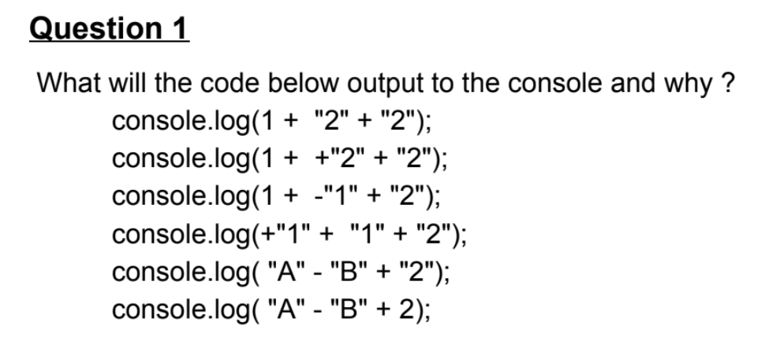

**Solution**

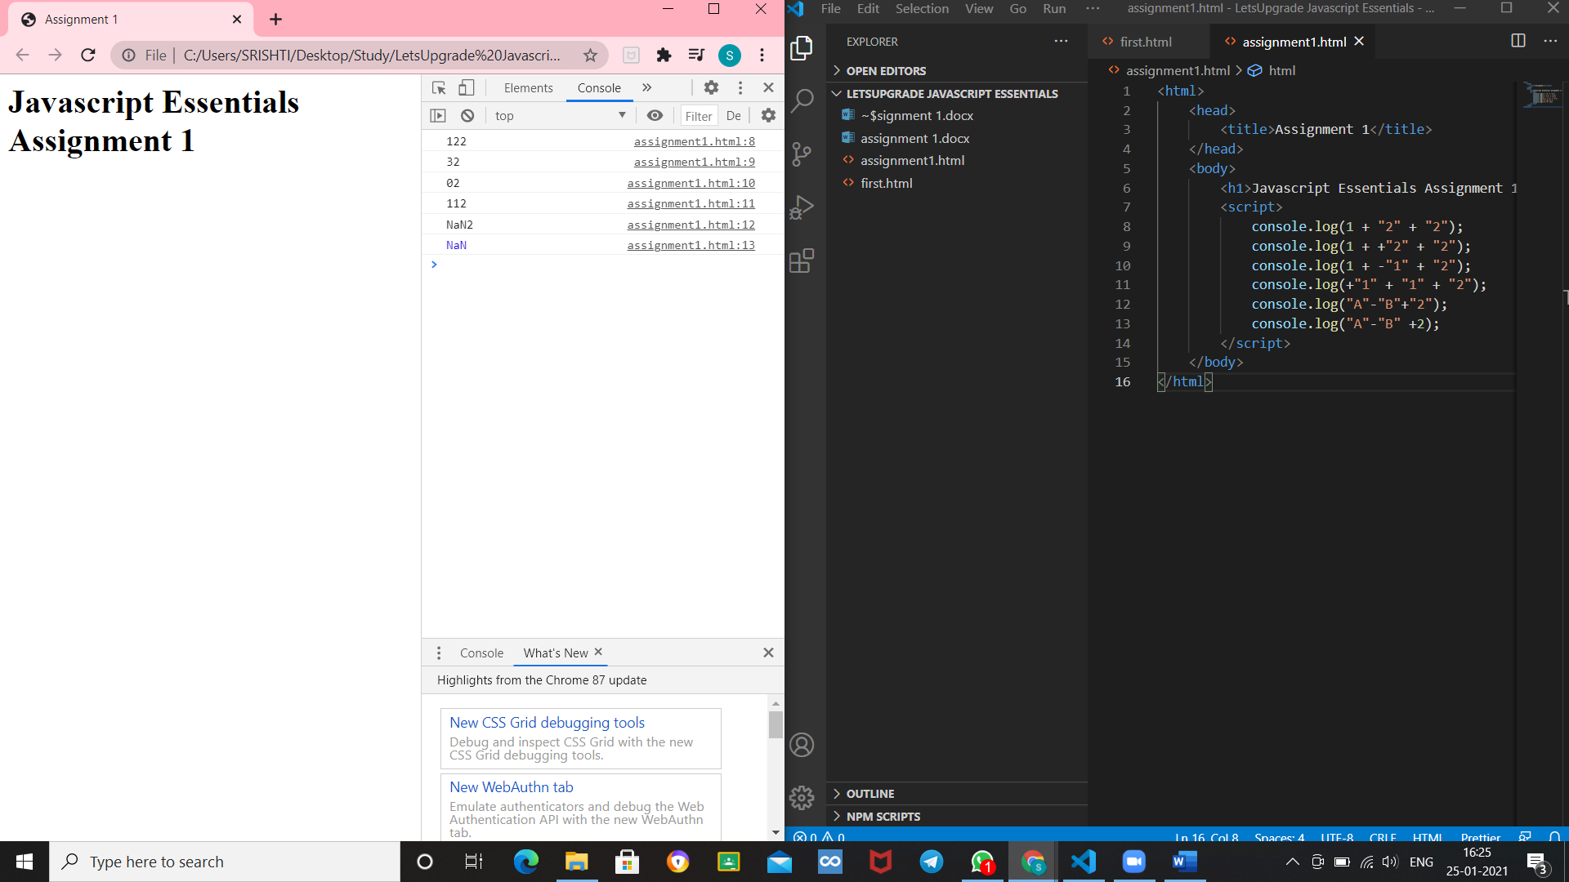

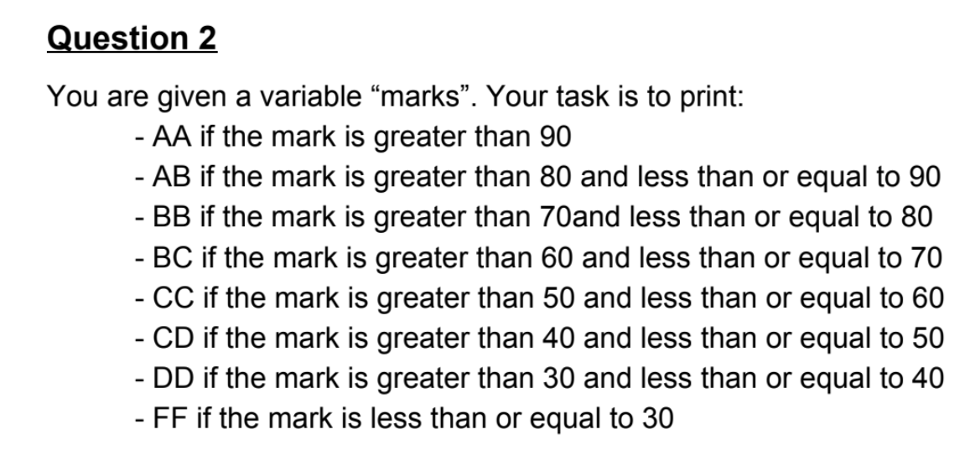

**Solution**

<html>

    <head>

        <title>Assignment 1</title>

    </head>

    <body>

        <h1>Javascript Essentials Assignment 1</h1>

        <script>

            // console.log(1 + "2" + "2");

            // console.log(1 + +"2" + "2");

            // console.log(1 + -"1" + "2");

            // console.log(+"1" + "1" + "2");

            // console.log("A"-"B"+"2");

            // console.log("A"-"B" +2);

            var marks=100;

                if (marks>90)

                {

                    console.log("AA");

                }

                else if(marks>80 && marks<=90)

                {

                    console.log("AB");

                }

                else if(marks>70 && marks<=80)

                {

                    console.log("BB");

                }

                else if(marks>60 && marks<=70)

                {

                    console.log("BC");

                }

                else if(marks>50 && marks<=60)

                {

                    console.log("CC");

                }

                else if(marks>40 && marks<=50)

                {

                    console.log("CD");

                }

                else if(marks>30 && marks<=40)

                {

                    console.log("DD");

                }

                else

                {

                    console.log("FF");

                }

        </script>

    </body>

</html>

**OUTPUT**

